EE 481/581 Microwave Engineering (Fall 2025)

Laboratory 6 Multiport Device Analysis- Part 1: CSI SDSM&T Report

Investigators _____________________________________________________
Supported by the work in your logbook, complete this initial report on your findings. Your supervisor will expect results to be backed up by calculations, measurements, references, etcetera in the logbook.
Device 1
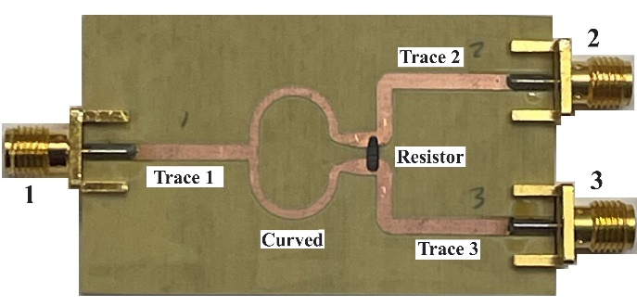
- Device is a _________________________________________________.
- The characteristic impedances of the ports (labeled 1, 2 & 3 on picture above) are:
Z₁ = ___________, Z₂ = ___________, & Z₃ = ___________.
- The Rogers Corporation RO4003C laminate thickness is d = _________________.
- On the picture above, what are the width W_{x}, length L_{x}, and characteristic impedances Z_{0,x} of:
Trace 1: W₁ = ___________, L₁ = ___________, & Z_{0,1} = ___________.
Trace 2: W₂ = ___________, L₂ = ___________, & Z_{0,2} = ___________.
Trace 3: W₃ = ___________, L₃ = ___________, & Z_{0,3} = ___________.
Curved: W_{c} = ___________, L_{c} = ____________ per side, & Z_{0,c} = ___________.
- Based on the device type and prior information, the suspected resistor value R = ___________.
- Expected center frequency f_{c}, low frequency f_{low}, and high frequency f_{high} of:
f_{c} = ___________, f_{low} = ___________, and f_{high} = ___________ (enter n/a if not applicable)
- Predicted [S]-matrix at f_{c} or a representative frequency: [S] =
- Is the device lossless? Yes / No (circle)
- Suggested test plan to confirm theories-

Device 2
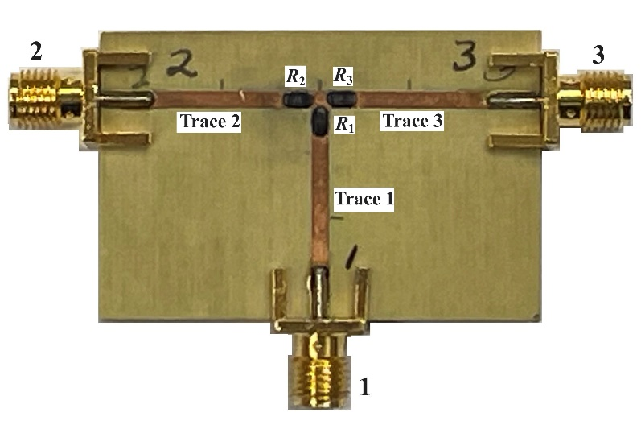
- Device is a _________________________________________________.
- The characteristic impedances of the ports (labeled 1, 2 & 3 on picture above) are:
Z₁ = ___________, Z₂ = ___________, & Z₃ = ___________.
- The Rogers Corporation RO4003C laminate thickness is d = _________________.
- On the picture above, what are the width W_{x}, length L_{x}, and characteristic impedances Z_{0,x} of:
Trace 1: W₁ = ___________, L₁ = ___________, & Z_{0,1} = ___________.
Trace 2: W₂ = ___________, L₂ = ___________, & Z_{0,2} = ___________.
Trace 3: W₃ = ___________, L₃ = ___________, & Z_{0,3} = ___________.
- The expected theoretical resistor values are:
R_{1,theory} = ___________, R_{2,theory} = ___________, and R_{3,theory} = ___________.
- The measured resistor values are:
R_{1,meas} = ___________, R_{2,meas} = ___________, and R_{3,meas} = ___________.
- Expected center frequency f_{c}, low frequency f_{low}, and high frequency f_{high} of:
f_{c} = ___________, f_{low} = ___________, and f_{high} = ___________ (enter n/a if not applicable)
- Predicted [S]-matrix at f_{c} or a representative frequency: [S] =
- Is the device lossless? Yes / No (circle)
- Suggested test plan to confirm theories

